

**T.C DOĞUŞ UNIVERSITY**

**FACULTY OF ENGINEERING COMPUTER ENGINEERING**

**Internship Management Project**

**Come 491 Project**

**Prepared by**

**Taner Ileri**  **20190301015**

**Ayça Sena Akın 20190301060**

**Bahadır Öztürk 20190301029**

**Koray Kocaelli 20190301055**

**MuhammedTalha Sakaoğlu 20190301057**

**Thesis Advisor**

**Asist. Prof. Dr. M Zahid Gürbüz**

**Istanbul, February 2024**



# PREFACE

We would like to thank, Assit. Dr. M.Zahid Gürbüz who has with us many phase of the project.

İstanbul, Febuary 2024 AYÇA SENA AKIN

BAHADIR ÖZTÜRK

KORAY KOCAELLİ

MUHAMMEDTALHA SAKAOĞLU

TANER İLERİ

# SUMMARY

In response to the perpetual advancement of technology, human beings have consistently endeavored to stay abreast of these developments. However, this endeavor is not without its challenges, as the rapid pace of technological evolution often leaves traditional systems outdated. Recognizing the need for adaptation, our initiative focuses on the creation of a comprehensive website to revolutionize the internship management process for university students. The current system often necessitates students to engage in a troublesome process of sending numerous emails and waiting for school responses. In contrast, our website establishes a dynamic and mutual relationship between students and advisors. This platform enables students to easily access essential documents and upload necessary information, creating a streamlined workflow. Advisors, in turn, can efficiently review submissions and provide timely permissions, transforming the internship management process into a more responsive and interactive experience for both parties. Also, advisors can check all their student's status and give them corrections. In certain situations, it is needed to make some mutual e-mailing eventually but in the general perspective web site make it minimal about it

Keywords: Intership Management, Dynamic Relationship, Upload Information

# ÖZET

Teknolojinin sürekli ilerlemesine karşılık insanoğlu sürekli olarak bu gelişmelere ayak uydurmaya çalışmaktadır. Ancak teknolojik evrimin hızlı temposu geleneksel sistemleri sıklıkla modası geçmiş bıraktığından, bu çabanın da zorlukları var. Uyarlama ihtiyacını kabul eden girişimimiz, üniversite öğrencilerine yönelik staj takip sürecinde devrim yaratacak kapsamlı bir web sitesinin oluşturulmasına odaklanıyor. Mevcut sistem çoğu zaman öğrencilerin çok sayıda e-posta gönderme ve okul yanıtlarını bekleme gibi zahmetli bir sürece girmelerini gerektirmektedir. Buna karşılık web sitemiz öğrenciler ve danışmanlar arasında dinamik ve karşılıklı bir ilişki kurar. Bu platform, öğrencilerin temel belgelere kolayca erişmesine ve gerekli bilgileri yüklemesine olanak tanıyarak akıcı bir iş akışı oluşturur. Danışmanlar da başvuruları verimli bir şekilde inceleyebilir ve zamanında izinler sağlayabilir, böylece staj yönetimi sürecini her iki taraf için de daha duyarlı ve etkileşimli bir deneyime dönüştürebilir. Ayrıca danışmanlar tüm öğrencilerinin durumunu kontrol edebilir ve onlara düzeltmeler yapabilir. Bazı durumlarda, sonunda karşılıklı e-posta göndermek gerekebilir ancak genel perspektifte web sitesi bu konuda bunu minimum düzeyde tutar.

Anahtar Kelimeler: Staj Takip Süreci, Dinamik İlişki, Temel Belgeler

**SYMBOLS**

**ABBREVIATIONS**

VS Visual Studio

IMS Inteship Management System

CQRS Command Query Responsibility Segregation

API  Application Programming Interface

IIS Internet Information Service

# CONTENTS

PREFACE ii

SUMMARY ii

ÖZET iii

CONTENTS iv

LIST OF FIGURES vii

LIST OF TABLES viii

SYMBOLS ix

ABBREVIATIONS x

REQUIREMENTS ANALYSIS DOCUMENT 1

1. INTRODUCTION 1

1.1. Purpose of the system 1

1.2. Scope of the system 1

1.3. Objectives and success criteria of the project 1

1.4. Definitions, acronyms, and abbreviations 1

1.5. References 1

1.6. Overview 1

2. CURRENT SYSTEM 2

3. PROPOSED SYSTEM 3

3.1. Overview 3

3.2. Functional requirements 3

3.3. Nonfunctional requirements 3

3.3.1. Usability 3

3.3.2. Reliability 3

3.3.3. Performance 3

3.3.4. Supportability 3

3.3.5. Implementation 3

3.3.6. Interface 3

3.3.7. Packaging 3

3.3.8. Legal 3

3.4. System models 3

3.4.1. Scenarios 3

3.4.2. Use case model 3

3.4.3. Object model 3

3.4.4. Dynamic model 3

3.4.5. Database model — ER diagram 3

3.4.6. User interface—navigational paths and screen mock-ups 3

4. GLOSSARY 4

PROJECT BUDGET AND TIME PLAN 5

5. INTRODUCTION 5

5.1. Gantt Chart 5

5.1. Project Budget 6

5.2. Project Phase Distribution 6

5.3. Other Tables 7

PROJECT SPECIFIC CONTENT 7

6. INTRODUCTION 7

6.1. ACCESSIBILITY 7

6.2. USER MANUAL 7

6.3. TEST PLAN 7

6.4. MAINTENANCE PLAN 7

CONCLUSION AND DISCUSSION 8

REFERENCES 9

APPENDIX 10

BIOGRAPHY 11

**LIST OF FIGURES**

Model 1 Use Case Model………………………………………

Model 2 Objecet Model…………………………………………

Model 3 Dynamic Model

Model 4 Database Model – ER diagram

Model 5 Gantt Chart

**LIST OF TABLES**

Table 1 Project Phase Distribution

Table 2 Other Tables - Meeting Information

**REQUIREMENTS ANALYSIS DOCUMENT**

**1 INTRODUCTION**

* 1. - **Purpose of the System**

Today, in an age where technology is rapidly evolving, educational processes must also keep up with this change. Students' internship processes play a critical role in their professional development. At this point, traditional internship book management and evaluation processes can be made more effective and efficient by supporting digitalization and technological innovations. We are planning that teacher can check the and keep it management and students can get forms and upload their internship documents.

**1.2** - **Scope of the System**

Students who want to apply for internship must follow the criteria determined by the universities. It must fill out the relevant internship application documents in accordance with the date ranges and internship regulations. Students whose application documents were approved as a result can start their internship programs officially. During the internship program, students should prepare their daily internship notebooks and submit them to the department that they are affiliated with at the end of the internship. They must submit the notebook they have completed. With the "Internship Management System" project developed within the scope of this study. This internship process carried out between has been combined under the roof of a web project and it is ensured that the transactions are carried out through this system. Accelerating, simplifying and facilitating the monitoring and management of the process is targeted.

**1.3** - **Objectives and Success Criteria of the Project**

Our main goal is to enable users within the system to perform their tasks easily and to ensure the flawless completion of operational practices in the system. For internship candidates, this involves being able to complete all necessary processes within the system, from the internship application process to the submission of documents, while simultaneously allowing their advisors to fulfill their responsibilities and duties towards the intern.

The project aims to facilitate the managing, addition, and control of essential documents in a structured manner, ensuring smooth operation without interruptions. The system should be capable of pausing operations when necessary and facilitating communication between the intern and the advisor. The communication should be reliable, traceable, transparent in its stages, and simple. These criteria are key success factors for this project.

**1.4** - **Definitions, Acronyms, and Abbreviations**

Internship Management System (IMS): The web-based platform developed for managing internship processes efficiently.

UML: Unified Modeling Language.

ISBN: International Standard Book Number.

**1.5** - **References**

Applying UML and Patterns, 3rd Ed., Craig Larman, Prentice-Hall, 2007

UML Distilled, 3rd Edition, Martin Fowler, Addison-Wesley, 2003

Head First Object Oriented Analysis and Design, Brett D. McLaughlin, Gary Pollice, Dave West, O'Reilly Media, 2006, ISBN: 059600867

Head First Design Patterns, by Eric Freeman, Elisabeth Robson and Bert Bates 2004, O'Reilly Media, ISBN: 0596007124

Software Engineering: Theory and Practice, 4th Ed., Pfleeger & Atlee, Prentice Hall, 2009

Thinking in C++, Bruce Eckel

**1.6** - **Overview**

This section will provide a brief summary of the document, highlighting key points such as the purpose, scope, objectives, and success criteria of the project.

**2 CURRENT SYSTEM**

In the past, the process of submitting internship notebooks required physical delivery, scanning, and subsequent emailing. This system led to complications and resulted in professors spending valuable time reviewing incomplete submissions. Each student had to be individually contacted for missing materials. To address these issues, we have implemented a new system to streamline the process and enhance efficiency. We have developed a dedicated website where both students and teachers can conveniently upload and access internship notebooks. This platform eliminates the need for manual handling and provides a user-friendly interface for swift and complete notebook submissions. This innovative approach not only saves valuable time for both students and professors but also ensures a more organized and accessible system for monitoring and managing internship notebooks. We believe that this improvement will greatly enhance the overall experience for all parties involved.

**3 PROPOSED SYSTEM**

**3.1 - Overview**

On our newly established website, distinct login credentials will be provided for students and teachers. Within the student portal, students will discover comprehensive guidelines detailing the content requirements for their internship notebooks. Additionally, an information system will be available, offering step-by-step instructions on the proper procedure for uploading internship notebooks. This dedicated space allows students to effortlessly submit their internship materials.

Teachers, with their separate login credentials, will gain access to a centralized platform where they can efficiently review and provide prompt feedback on students' notebooks. This enhanced control and visibility enable a more streamlined feedback process, ultimately fostering a more efficient and organized system for both students and teachers.

**3.2 - Functional Requirements**

Accessing Information and Documents:

Users will have the capability to access essential information and documents related to internship documentation. Relevant Information about Internship Procedures: Users will gain access to pertinent details concerning internship procedures and dates.

Document Upload Functionality: Users can upload the necessary documents to the system within designated timeframes.

Document Visibility: Both advisors and interns will be able to view documents uploaded to the system. Document Management

Functions: Users can perform actions such as editing, approving, or rejecting documents. Missing

Document Requests: The system allows the generation of requests for missing documents. Facilitated

Communication: The platform facilitates effective communication between interns and advisors.

Advisors' Activity Managing: Advisors will have the ability to manage and monitor activities through their individual dashboards.

**3.3 - Nonfunctional Requirements**

**3.3.1 - Usability:**

User Interface: The system should have an intuitive, visually appealing and user-friendly user interface.

Accessibility: Training: Minimal training should be required for both students and teachers to use the system effectively.

Consistency: The user interface elements and interactions should be consistent throughout the system.

**3.3.2 - Reliability:**

Availability: The system should be available for use 99% of the time during standard operating hours.

Fault Tolerance: The system should be able to recover gracefully from hardware or software failures without data loss.

Data Integrity: Measures should be in place to ensure the accuracy and consistency of data.

**3.3.3 - Performance:**

The system should support concurrent access by multiple users without significant degradation in performance.

**3.3.4 - Supportability:**

Capability to rectify errors and provide ongoing system support.

**3.3.5 - Implementation:**

Technology Stack: Clearly define the technologies and frameworks used in the system's implementation.

Coding Standards: Adherence to coding standards should be maintained for consistency and maintainability.

Version Control: Source code should be managed using a version control system (e.g., Git).

**3.3.6 - Interface:**

User Interfaces: Specify the interfaces for both students and teachers, ensuring they are user-friendly and meet the needs of their respective roles.

Integration Points: Define any interfaces or APIs for potential integration with external systems.

**3.3.7 - Packaging:**

Deployment: Provide clear instructions for deploying the system, including any dependencies and system requirements.

Updates: Outline procedures for applying updates or patches to the system.

**3.3.8 - Legal:**

Compliance: Ensure that the system complies with relevant legal requirements, including data protection laws and university policies.

Licensing: Specify the licensing terms and conditions for the use of the system.

**3.4 - System Models**

**3.4.1 - Scenarios**

Actor: Intern

Preconditions: The intern is logged into the system.

Trigger: The intern navigates to the "Submit Documents" section.

Main Flow:

The intern selects the option to submit an internship report.

The system displays a form with fields for report details, upload, and submission.

The intern fills in the required details and uploads the internship report.

After submission, the system confirms successful document submission.

Postconditions: The internship report is successfully uploaded and visible to the advisor.

Actor: Teacher

Preconditions: The teacher is logged into the system.

Trigger: The teacher navigates to the "Review Student" section.

Main Flow:

The teacher selects the name of the student and views the student's internship notebook.

The system displays the documents uploaded by the student, including the internship notebook.

After reviewing the internship notebook, the teacher selects relevant options to provide feedback to the student.

The teacher adds feedback to the student and determines approval or rejection options.

The system confirms the successful completion of the feedback process.

Postconditions: The student can view the teacher's feedback and, if necessary, make corrections to the documents.

**3.4.2 - Use Case Model**

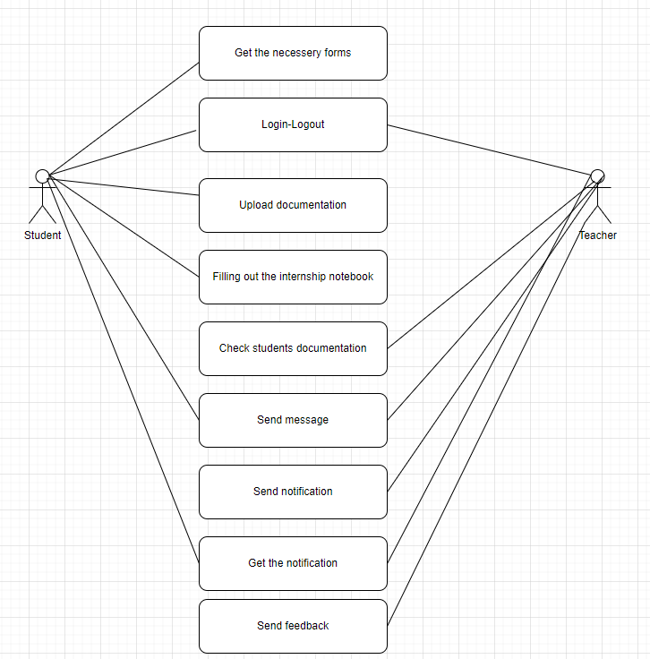

Model 1

**3.4.3.1 - Object Model – Packages Mapped**

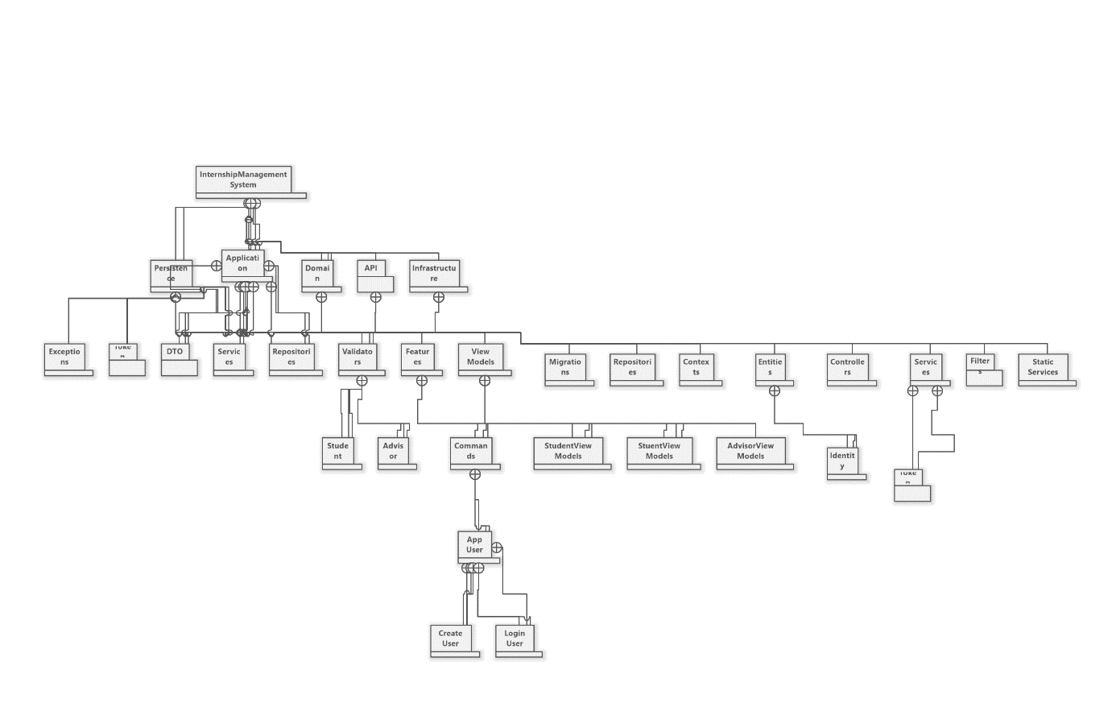

Model 2

**3.4.3.2 - Object Model**

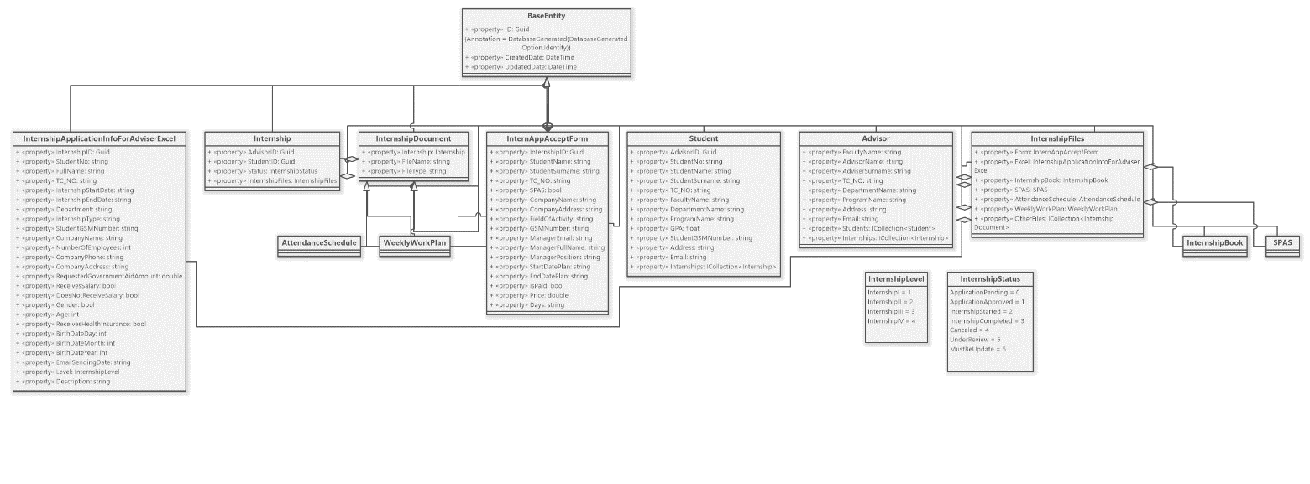

Model 3

**3.4.4 - Dynamic Model**

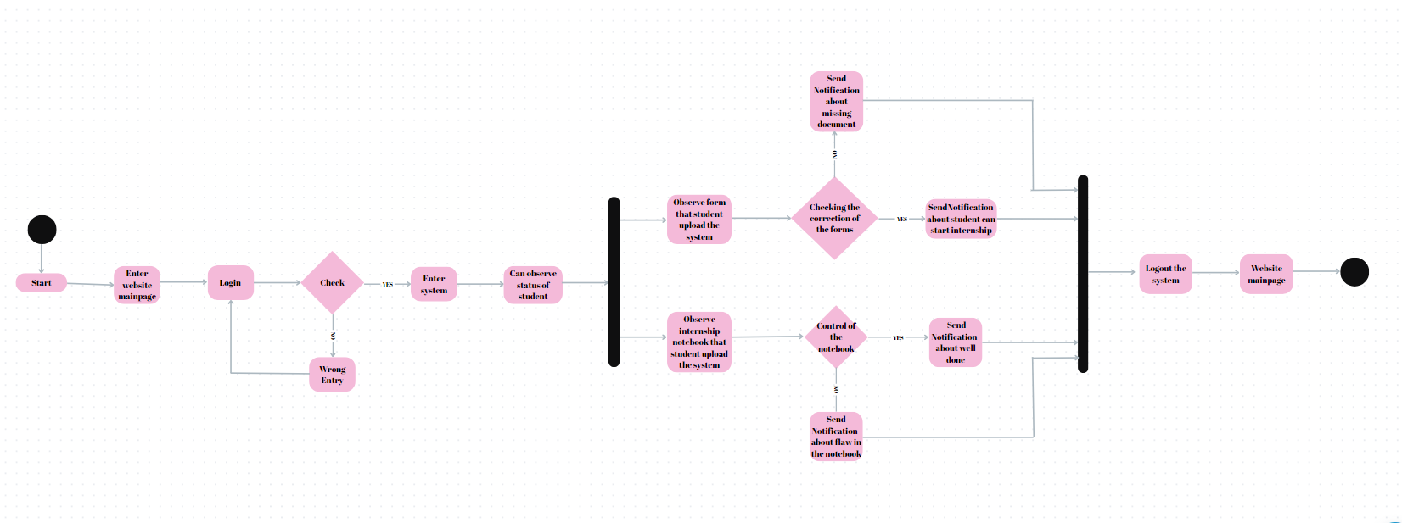

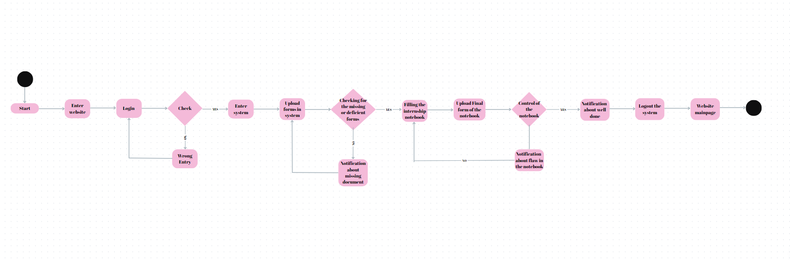

Model 4

**3.4.5 -** **Database model — ER diagram**

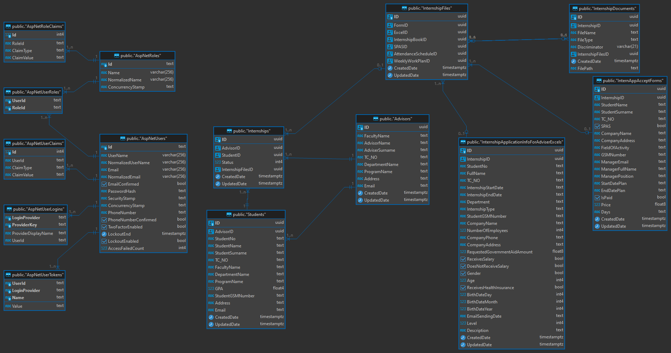

Model 5

**3.4.6 - User Interface-Navigational Paths and Screen Mock-ups**

Home Page



Internship directive



Notebook



Intership Forms



Employment certificate



Student and Advisor Login Screen

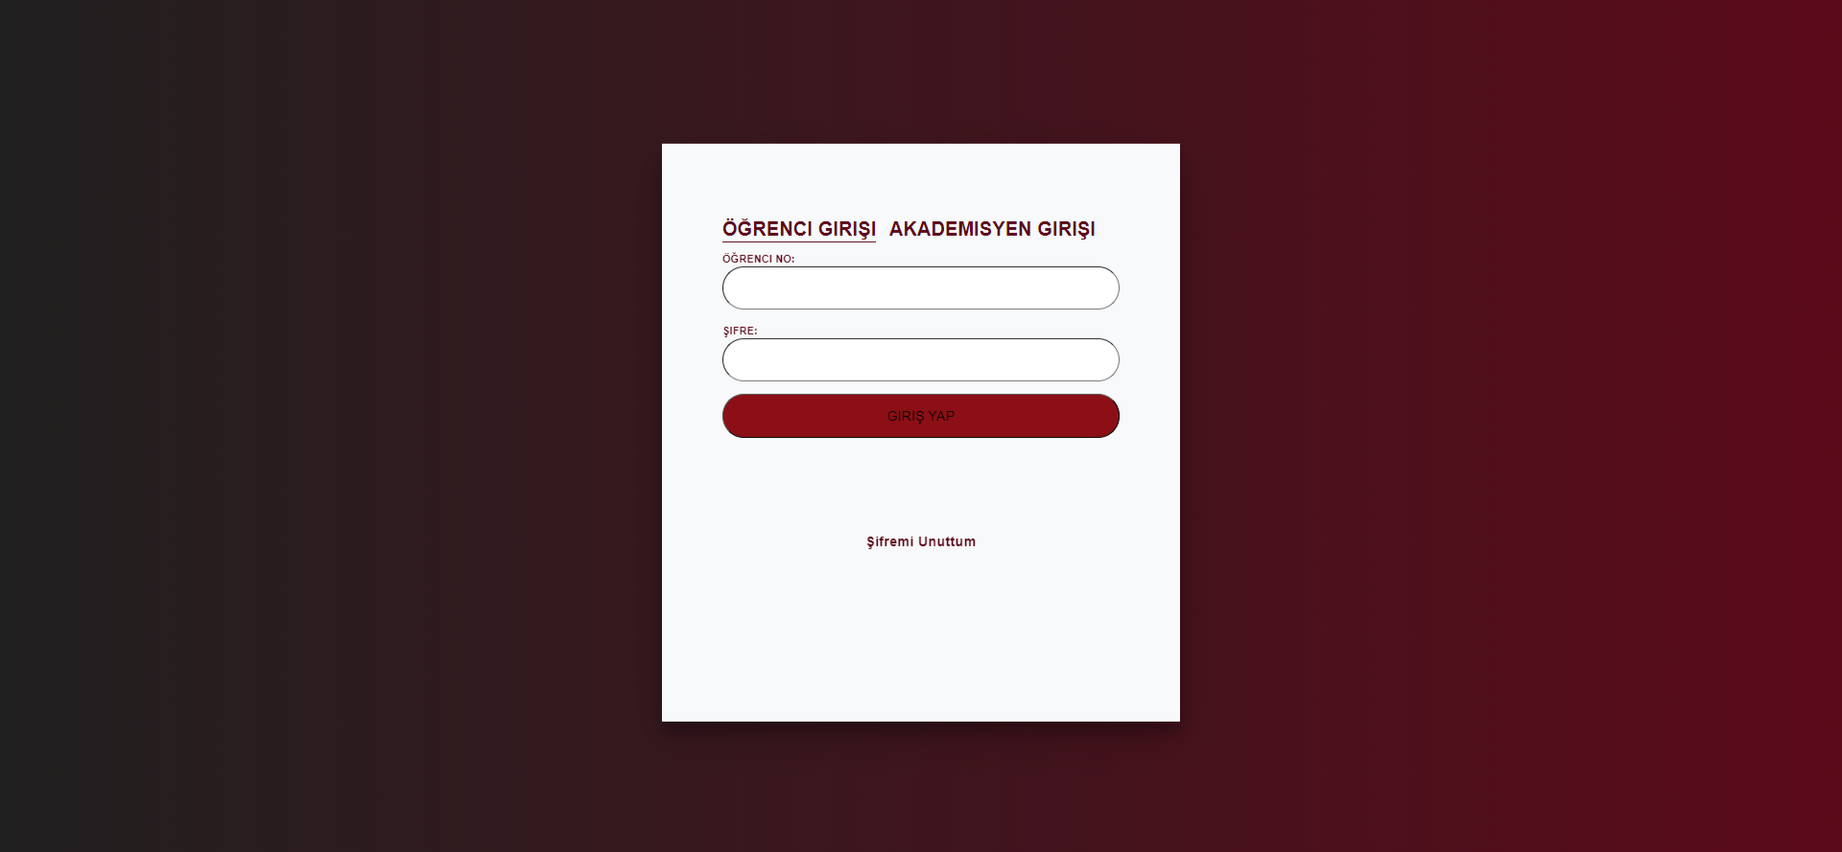

Student Info

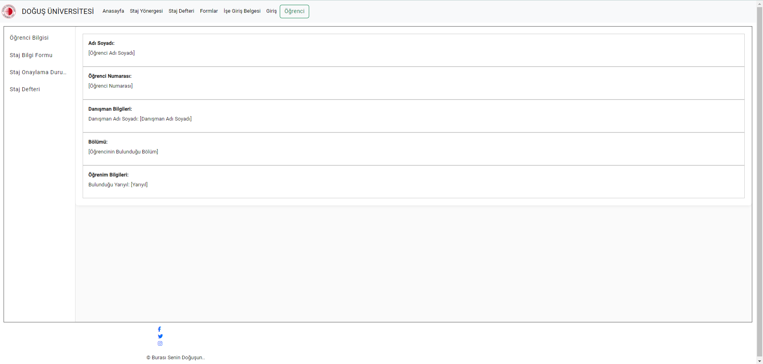

Intership Information Form (excel form)

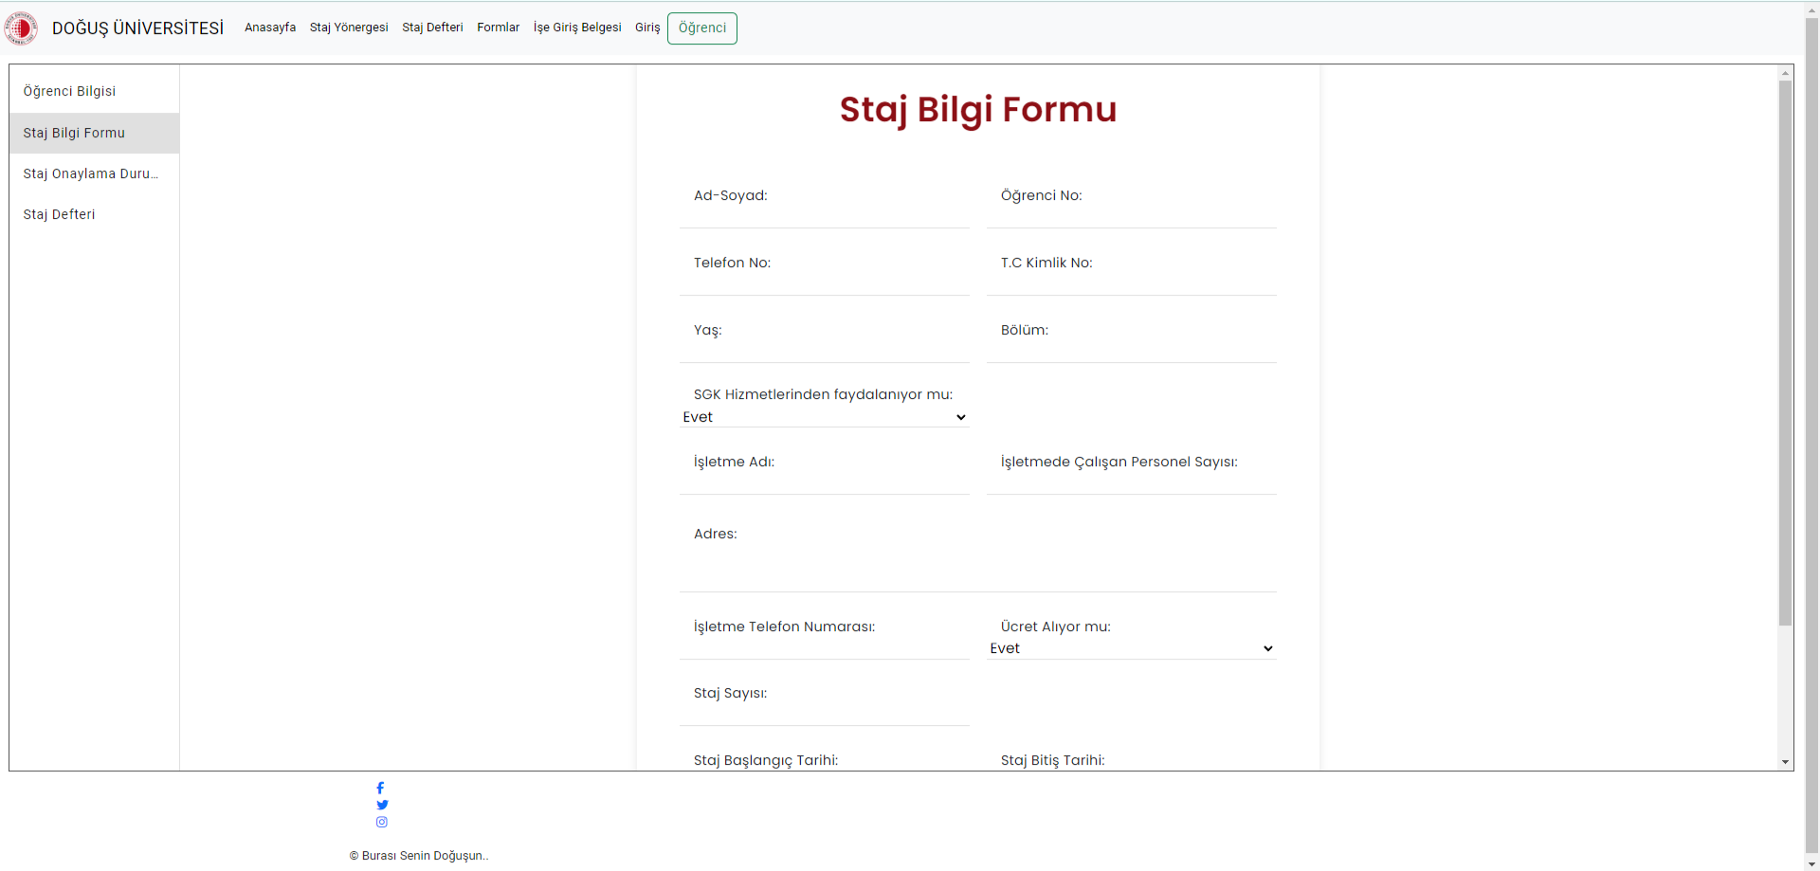

Intrership Approval

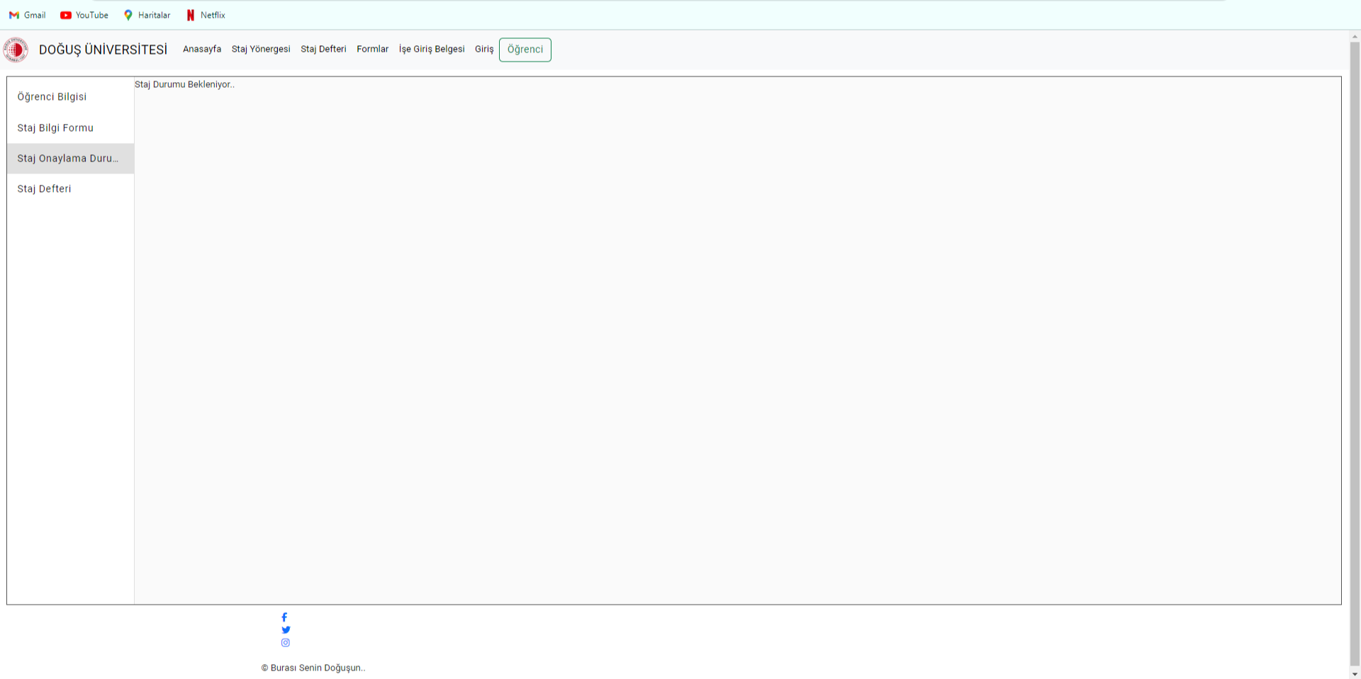

Intership Notebook

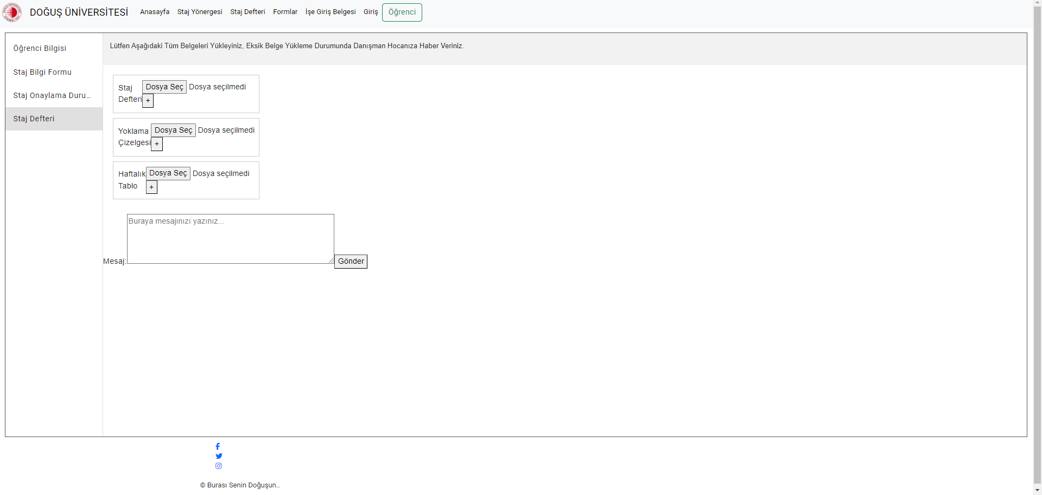

**4 GLOSSARY**

Intern: A student undergoing an internship program.

Advisor: A faculty member responsible for guiding and evaluating the intern.

Document Upload Functionality: The feature allowing users to upload required internship documents.

Feedback Process: The mechanism for providing and receiving feedback between interns and advisors.

**PROJECT BUDGET AND TIME PLAN**

**5. INTRODUCTION**

A project plan is one of the crucial components for the success of a project. It is used to document and communicate expectations, control the schedule and delivery, and assess and manage risks. Generally, it serves as a roadmap for everyone involved in the project.

**5.1 Gantt Chart**

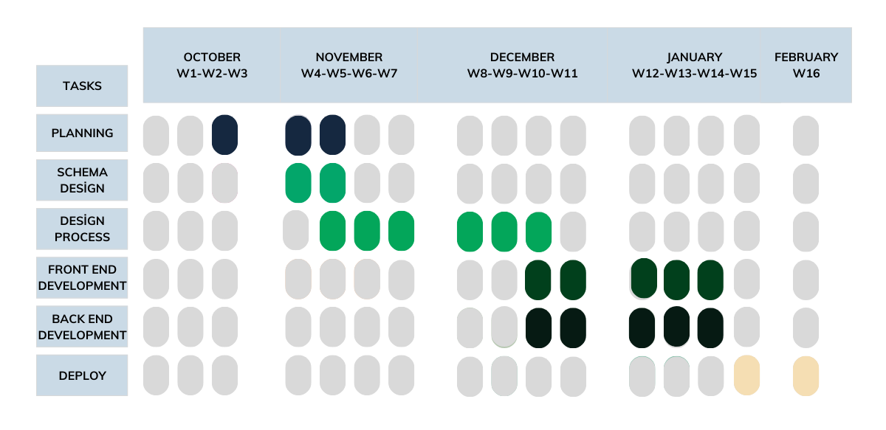

Model 6

**5.2 Project Budget**

No purchase of assets took place in the graduation project, and consequently, no expense was incurred. Activities involving the acquisition of materials or equipment did not occur within the project scope. managed within the existing resources.

**5.3 Project Phase Distribution**

|  |  |  |
| --- | --- | --- |
| **Planning and Analysis** | **Desing** | **Application** |
| %40 | %30 | %30 |

*Table 1*

**5.4 Other Tables - Meeting Information**

|  |  |
| --- | --- |
| **November 2023** | **December 2023** |
| 10.11.2023-Friday | 15.12.2023-Friday |
| 17.11.2023-Friday | 22.12.2023-Friday |
| 24.11.2023-Friday |  |

|  |
| --- |
| **January 2023** |
| 10.11.2023-Friday |
| 17.11.2023-Friday |

*Table 2*

**PROJECT SPECIFIC CONTENT**

**6. INTRODUCTION**

In the dynamic landscape of contemporary education, the Internship Tracking System project emerges as a transformative solution to modernize and optimize internship processes. Recognizing the crucial role of internships in shaping students' professional journeys, the system integrates digitalization and technological innovations to bring efficiency and effectiveness to traditional internship management. This web-based platform offers a comprehensive solution for students seeking internships and teachers overseeing these crucial experiences. The project envisions a seamless journey for internship candidates, providing an intuitive interface for the entire process, from adhering to university criteria during application to the official commencement of internship programs. Throughout the internship, students are equipped to maintain and submit daily internship notebooks, streamlining administrative tasks for both students and departmental staff. The platform's design accelerates, simplifies, and centralizes the management and monitoring of internships, marking a significant departure from conventional practices. In aligning with broader educational objectives, the Internship Tracking System seeks to achieve a harmonious blend of technology and pedagogy. The overarching goal is to empower users within the system, ensuring they can effortlessly navigate tasks, complete operational practices, and engage in transparent communication. The success of the project is contingent on its ability to establish a user-friendly environment that enhances the internship experience, offering tangible benefits to students and facilitating effective communication between interns and advisors.

**6.1. Accesibilty**

The targeted users in this project are the students of the Computer Engineering Department at Doğuş University.

Formun Üstü

**6.2.****User Manual**

1. When students access the website, they encounter a page related to internships containing the necessary information.
2. Students log in with their school ID and passwords, and upon login, they are prompted to fill in student information, confirm the form submission, and upload internship diaries.
3. Students must complete the information form first to obtain internship approval; without completing the form, approval is not possible.
4. After receiving confirmation, students are required to continue uploading their internship notebook.

**6.3.**  **Test Plan**

There is currently no test plan in our application.

**6.4 Maintenance Plan**

Backed by redundant servers and disk backups, maintenance and upgrade procedures can be executed as needed. Planned changes can be implemented on passive servers while the redundancy systems are in an active or passive state

**CONCLUSION AND DISCUSSION**

Our project holds a pivotal role in streamlining the internship process, aiming to create a visually appealing platform that ensures both students and advisors can navigate effortlessly without experiencing visual fatigue. The website has been meticulously designed to provide a user-friendly interface, recognizing the importance of a seamless experience for students who will undergo three internships. While the deployment phase is yet to be completed, we remain optimistic about refining the project further to enhance its usability for both students and advisors. The objective is to create a platform that not only meets but exceeds the expectations of its users, providing a robust and efficient system for managing the internship process. Drawing from our extensive experience in project management within our team, we are confident that these skills will seamlessly transition into our professional careers. The lessons learned from our journey so far have equipped us with the ability to efficiently collaborate and overcome challenges, an invaluable asset for the workplace. However, it's important to acknowledge that our current system falls short of our envisioned greatness. We recognize that there were some suboptimal decisions made during the development and design phases, limiting our ability to implement certain features. Despite these challenges, we are committed to continuous improvement and are dedicated to working tirelessly until we achieve a successful and impactful deployment of the project. The resilience of our team and the lessons learned from past mistakes will undoubtedly contribute to the eventual success of our endeavor.

**REFERENCES**

1. Applying UML and Patterns, 3rd Ed., Craig Larman, Prentice-Hall, 2007

2. UML Distilled, 3rd Edition, Martin Fowler, Addison-Wesley, 2003

3. Head First Object Oriented Analysis and Design, Brett D. McLaughlin, Gary Pollice, Dave West, O'Reilly Media, 2006, ISBN: 059600867

4. Head First Design Patterns, by Eric Freeman, Elisabeth Robson and Bert Bates 2004, O'Reilly Media, ISBN: 0596007124

5. Software Engineering: Theory and Practice, 4th Ed., Pfleeger & Atlee, Prentice Hall, 2009 6. Thinking in C++, Bruce Eckel

7. <https://github.com/gncyyldz>

8. <https://www.gencayyildiz.com/blog/\>

**APPENDIX**

**BIOGRAPHY**

Muhammedtalha Sakaoğlu

My name is Muhammedtalha Sakaoğlu. I completed my primary education in multiple cities and schools. I was born in 1997, and my interests are currently focused on backend architectures; however, I don't find myself creative on the interface side. I have lost faith in the idea that education can be obtained solely from school. Perhaps I can provide a summary: Education can be made more effective through a combination of research passion and being rewarded for success. I believe that the titles of those who accomplish good and different tasks should be elevated and rewarded. This can allow individuals to keep their minds open in a system where they can acknowledge that making mistakes is part of being human.

Taner İleri

I was born on October 25, 2000. I spent my entire education life in Tekirdağ until high school. I studied at Ramazan Yaman Science High School in Kırklareli Lüleburdaz until the 11th grade. In the 12th grade, I transferred to Çorlu Nazmi Arıkan Private Science Schools. I am currently continuing my education at Doğuş University.

Ayça Sena Akın

Born on May 26, 2000, in the Pendik district of Istanbul, commenced her educational journey. She spent the initial years of his high school education at Behiye Dr. Nevhiz Işıl Anatolian High School and later transferred to Atalar Fen Bilimleri High School for his final years. In 2019, earned admission to Doğuş University, where he is currently progressing as a fourth-year student. With aspirations to specialize in frontend development in his future professional endeavors, she actively engages in projects to fulfill this career goal.

Koray Kocaelli

I was born in Edirne on March 27 2000, and I went to school in Kırklareli Babaeski all the way up to high school. At Lüleburgaz Anatolian High School in Kırklareli Lüleburgaz, I continued my study. I'm currently attending Doğuş University to further my academic career. I am a final year student in computer engineering. I am deeply passionate about both backend and frontend development, actively honing my skills in both areas. Currently, I am gaining hands-on experience as a Java Software Developer Intern at Kafein Technology Solutions, where I am applying and enhancing my knowledge in both backend and frontend technologies.